

**A.V. Parekh Technical Institute, Rajkot**

**Computer Department**

**Pipelining in Computer Architecture**

**Presented By: Vaiyani Anisha (216020307074), Vasani Jenisa (216020307080), Sarvaiya Riya (216020307095)**

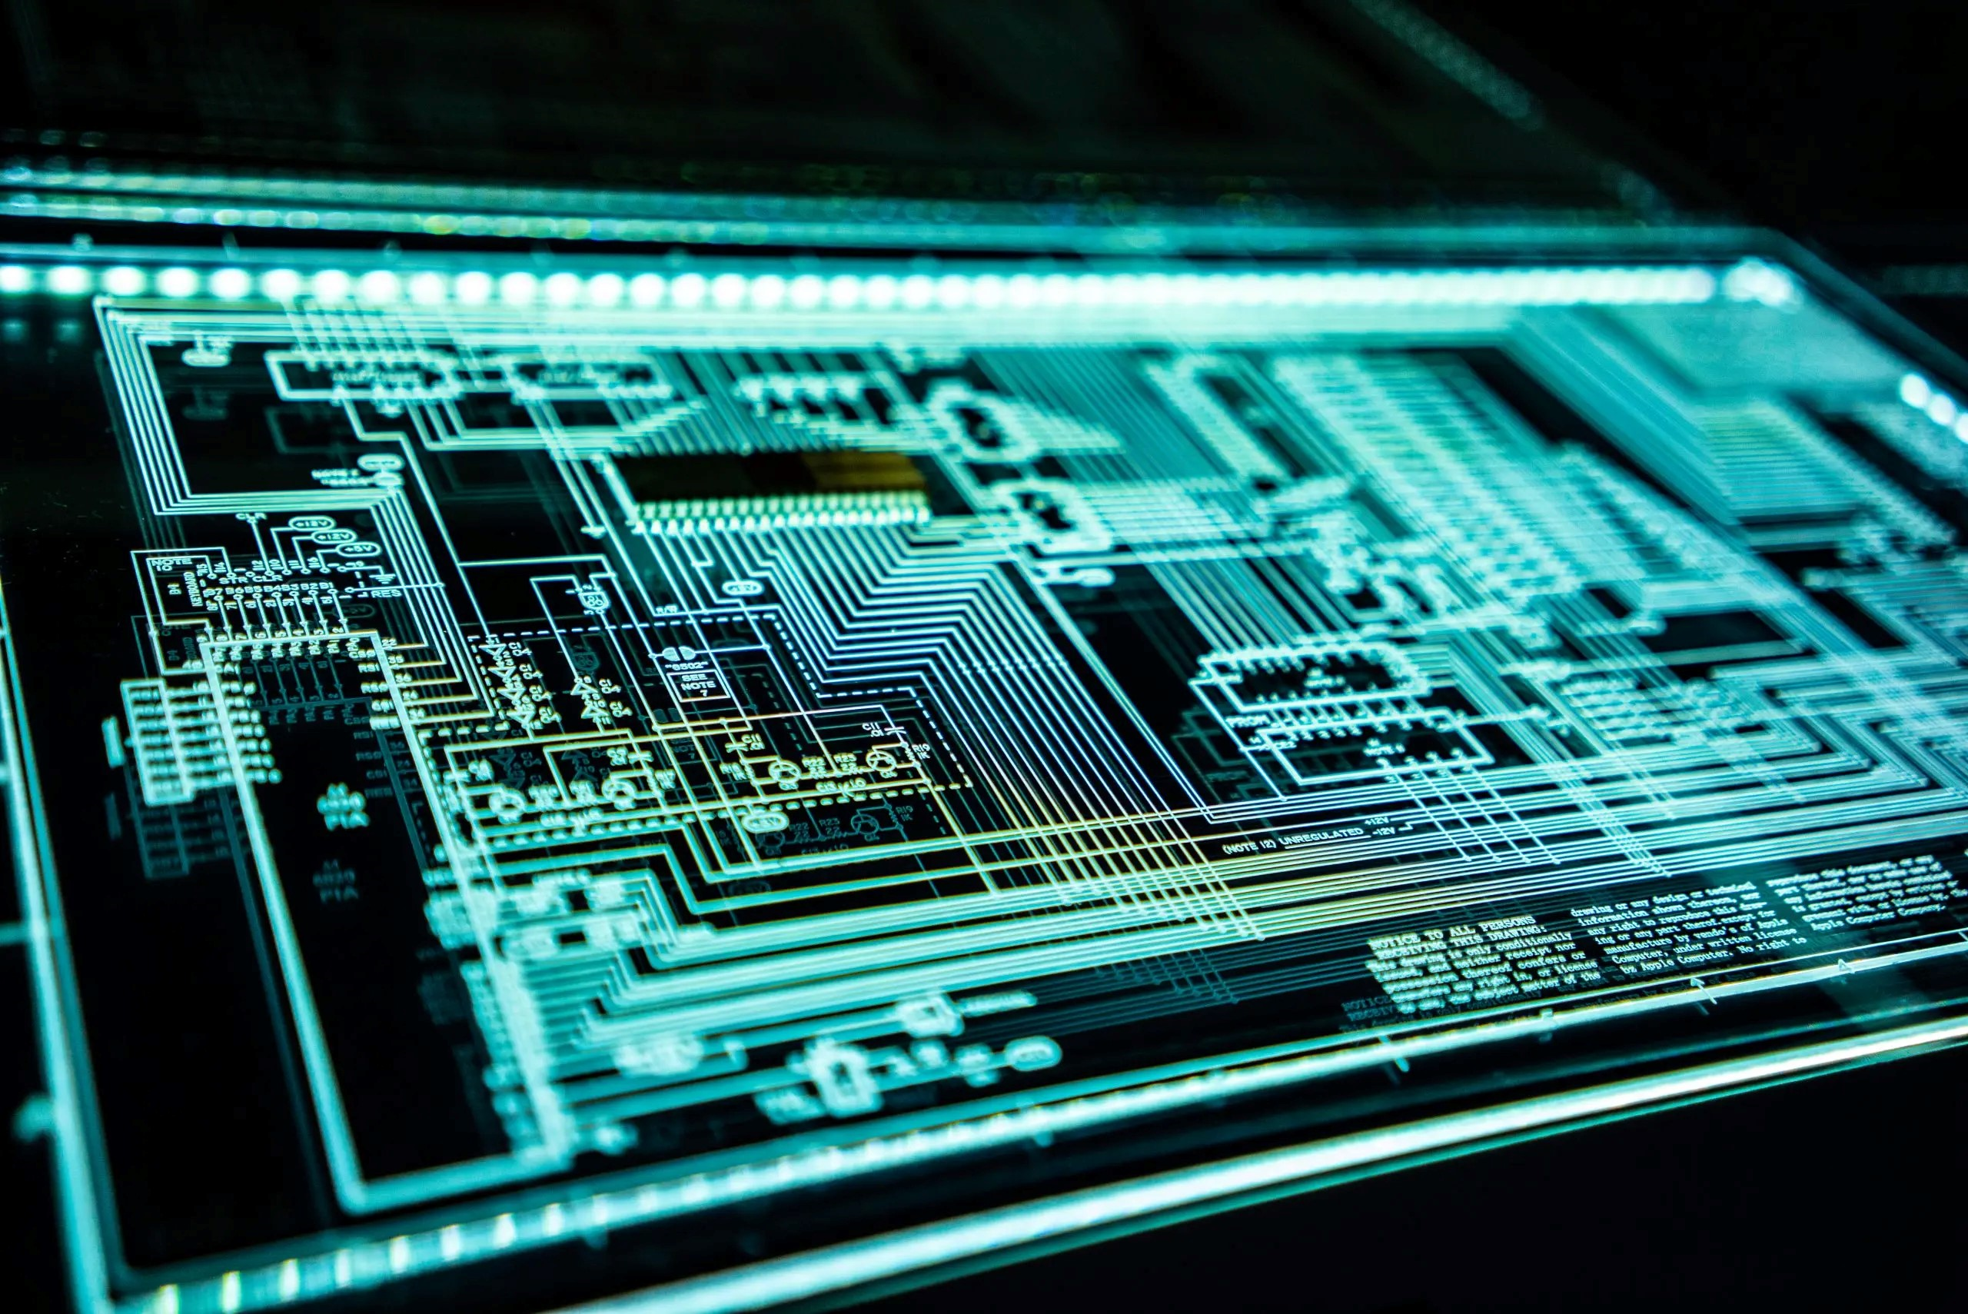

* In pipeline system, each segment consists of an input register followed by a combinational circuit. The register is used to hold data and combinational circuit performs operations on it. The output of combinational circuit is applied to the input register of the next segment

## **pipeline system:**

* Pipelining is the process of accumulating instruction from the processor through a pipeline. It allows storing and executing instructions in an orderly process .It is also known as pipeline processing.
* It is the technique where multiple instructions are overlapped during execution. Pipeline is divided into stages and these stages are connected with one another to form a pipe like structure. Instruction enter from one end and exit from another end.

## **Introduction:**

## **Types of pipeline:**

* It is divided into

1. Arithmetic Pipeline 2. Instruction Pipeline

## **Arithmetic pipeline:**

## **Example:**

* The input to the Floating Point Adder pipeline is:

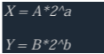

* Arithmetic pipelines are usually found in most of the computers. They are used for floating point operations, multiplication of fixed point numbers etc.

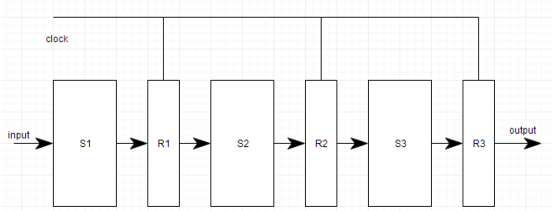

## **Example:**

* An instruction pipeline reads instruction from the memory while previous instructions are being executed in other segments of the pipeline.
* Thus we can execute multiple instructions simultaneously. The pipeline will be more efficient if the instruction cycle is divided into segments of equal duration.

## **Instruction pipeline:**

* Ina car manufacturing industry, huge assembly lines are setup and at each point, there are robotic arms to perform a certain task, and then the car moves on ahead to the next arm.

## **Pipeline Conflicts**

## **Instruction pipeline operations:**

1. Fetch instruction (FI)
2. Decode instruction (DI)
3. Calculate operands (CO)
4. Fetch operands (FO)
5. Execute instructions (EI)
6. Write result (WR)
7. Timing Variations
8. Data Hazards
9. Branching
10. Interrupts
11. **Data Dependency**

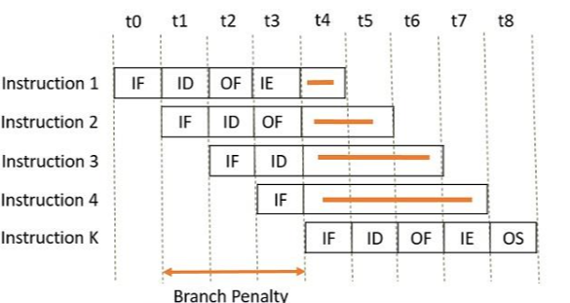

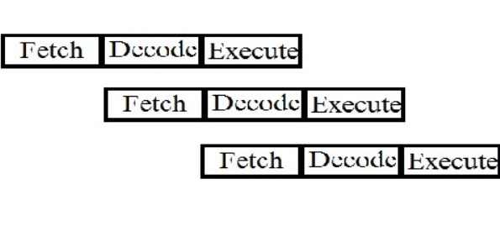

## **Advantages:**

## **Disadvantages:**

1. The design of pipelined processor is complex and costly to manufacture.
2. The instruction latency is more.
3. The cycle time of processor is reduced.
4. It increases the throughput of the system
5. It makes the system reliable.

* <https://www.lkouniv.ac.in/site/writereaddata/siteContent/202004221613338445rohit_engg_pipelining_and_hazzard.pdf>
* <https://www.techtarget.com/whatis/definition/pipelining>
* <https://www.javatpoint.com/pipelining>

## **References:**

**LIFE CYCLE OF INSTRUCTION**

**PIPELINING**